Disability-Inclusive Checklist:
Building Accessible Events

Movie Screening

Event Description

Your group wants to host a movie screening on a Friday night. After a vote, you have decided on the 2012 coming-of-age drama The Perks of Being a Wallflower.

You reserve a room with that has theatre-style chairs. It also has a screen, speaker, and projector system that are connected to a desktop at the front.

Your group has enough funding to buy a small popcorn machine, kernels, butter, salt, and a few two-liter bottles of soda.

. . .

The next few pages have pictures of the location, a list of materials, and other details to take into consideration as you analyze your event.

How can your group make this event more accessible
to students with disabilities?

Location


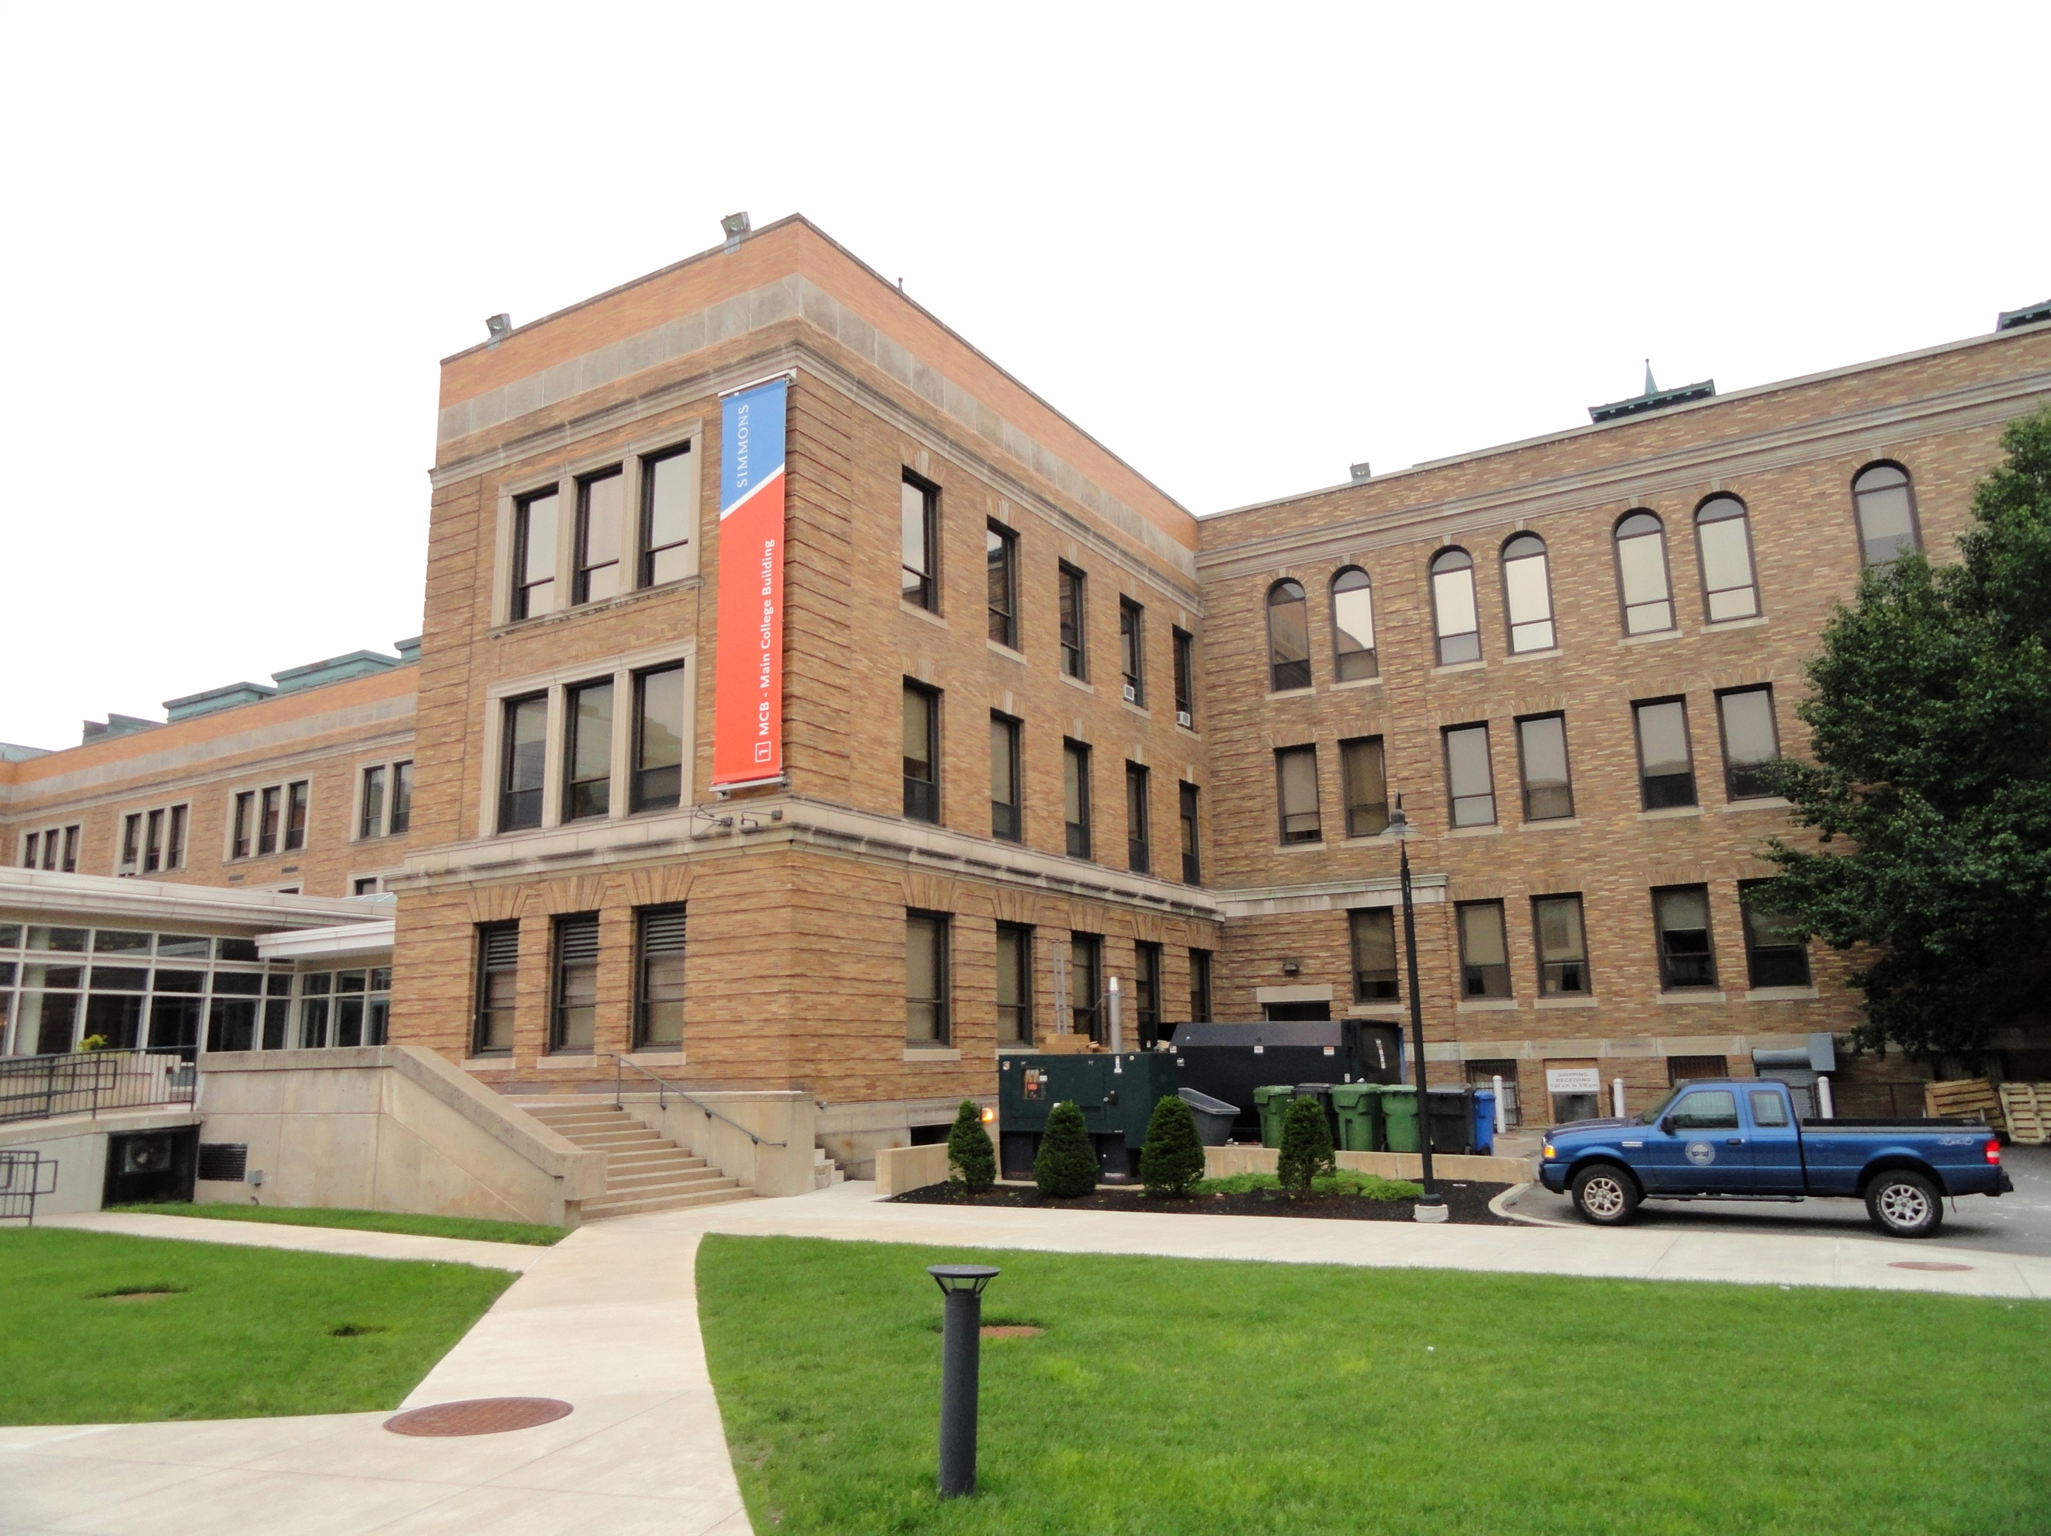

Materials





Other Details


Other Details

“Brad shows up to school with bruises on his face having been caught by his father having sex with Patrick. Brad lies, saying that he was jumped and beaten up. Brad distances himself from Patrick, calling him a "faggot" causing Patrick to punch him. Brad's friends begin beating Patrick, but Charlie forcefully intervenes, then blacks out. When he recovers he finds that he has bruised knuckles and Brad's friends are on the floor, incapacitated. Sam and Patrick express their gratitude to Charlie, and the three become friends again.

“Patrick tries to cope with what happened with Brad, and at one point kisses Charlie, but immediately apologizes afterwards. Charlie keeps getting worse after the blackout. Sam is accepted into Penn State, and breaks up with Craig on prom night after learning he has been cheating on her. The night before she departs, she brings Charlie to her room. They confide in each other and kiss, but when Sam touches Charlie's thigh, he experiences a momentary flashback of his Aunt Helen, which he passes off as nothing, and they continue to kiss. After she leaves for college, though, his emotional state deteriorates and his flashbacks worsen. He calls his sister blaming himself for Helen's death, and admits he may have wanted it to happen. His sister realizes he is in trouble and calls the police. Charlie passes out as they burst through the door and comes to in a hospital, where psychiatrist Dr. Burton (Joan Cusack) manages to bring out Charlie's repressed memories which reveals that his aunt sexually abused him.”

-from the Wikipedia page for The Perks of Being a Wallflower (film) plot synopsis

