Disability-Inclusive Checklist:
Building Accessible Events

Themed Dance

Event Description

Your group wants to host a dance on a Friday night. The group votes on potential themes and lands on a hip-hop/rap theme.

You reserve a conference hall and decide that you will temporarily store the chairs away to make room for the dance floor.

Your group is putting together a playlist and a list of refreshments as well.

. . .

The next few pages have pictures of the location, a list of materials, and other details to take into consideration as you analyze your event.

How can your group make this event more accessible
to students with disabilities?

Location
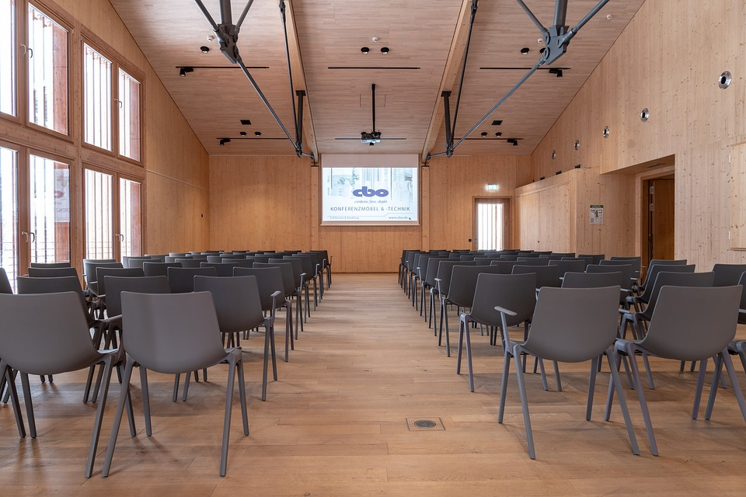

Materials

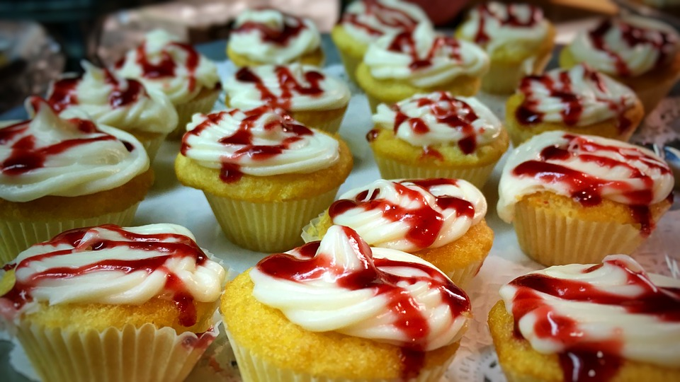

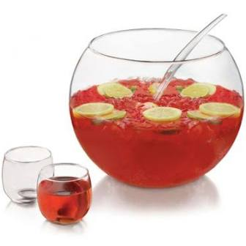

Other Details

From a proposed track list:

Airplanes – B.o.B. ft. Hayley Williams
Big Ole Freak – Megan Thee Stallion
Big Poppa – The Notorious B.I.G.
California Love – 2Pac
Can I Kick It? – A Tribe Called Quest
Crank That (Soulja Boy) – Soulja Boy Tell’em
Energy – Drake
Express Yourself – N.W.A.
Freak Nasty – Rico Nasty
Gucci Gang – Lil Pump
Money – Cardi B
Natural Born Killaz – Dr. Dre & Ice Cube
POWER – Kanye West
Rap God – Eminem
Super Bass – Nicki Minaj
This Is America – Childish Gambino
U.N.I.T.Y. – Queen Latifah
Yonkers – Tyler The Creator
Other Details

“Journey with me into the mind of a maniac
Doomed to be a killer since I came out the nut sack
I'm in a murderous mind state with a heart full of terror
I see the devil in the mirror
Buck-buck, lights out
Cause when I grab my sawed off, n----s get hauled off
(Barrel one) [gunshot sound] tears your mothaf----n' flesh
(Barrel two) [gunshot sound] tears your fuckin' heart out your chest”

-Dr. Dre & Ice Cube, Natural Born Killaz (1994)

“Lickwood means rewind, a gunshot means forward
You requested it so we rewind

[several rounds of gunshots]

Yeah
Way, way, way up
Turn it all up
Yeah
Look

I got enemies, got a lotta enemies
Got a lotta people tryna drain me of my energy”

-Drake, Energy (2015)

