Disability-Inclusive Checklist:
Building Accessible Events

Baseball Game

Event Description

Your group wants to take a few residents off campus to a professional sports game. After a vote, your group decides on baseball.

You look at the stadium seating chart, assess your budget, and get a group package for tickets. Your group will also be responsible for budgeting and executing a transportation plan to get students to and from the stadium.

. . .

The next few pages have pictures of the location, a list of materials, and other details to take into consideration as you analyze your event.

How can your group make this event more accessible
to students with disabilities?

Location

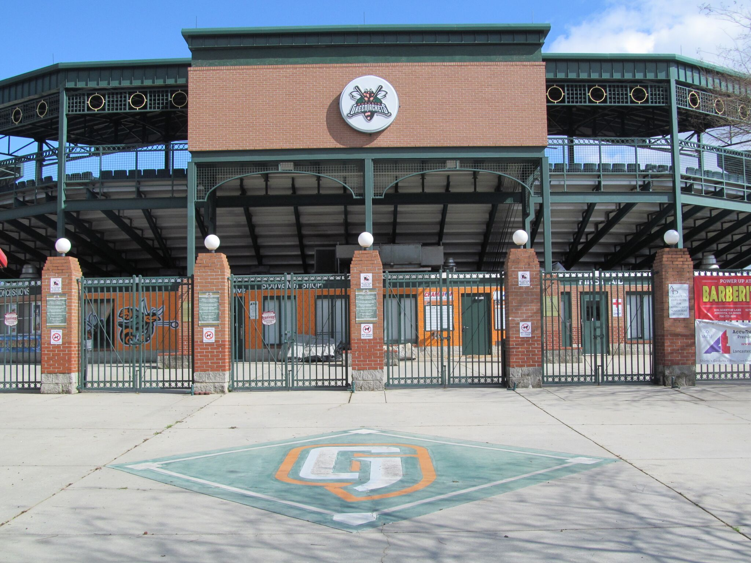


Transportation



